Continual lifelong learning with neural networks: A review

1. Introduction

For overcoming catastrophic forgetting, learning systems must, on the one hand, show the ability to acquire new knowledge and refine existing knowledge on the basis of the continuous input and, on the other hand, prevent the novel input from significantly interfering with existing knowledge.

For a stable continuous lifelong process, two types of plasticity are required: (i) Hebbian plasticity for positive feedback instability, and (ii) compensatory homeostatic plasticity which stabilizes neural activity.

Importantly, the brain must carry out two complementary tasks: generalize across experiences and retain specific memories of episodic-like events.

2. Biological aspects of lifelong learning

2.1. The Stability–Plasticity Dilemma

As humans, we have an astonishing ability to adapt by effectively acquiring knowledge and skills, refining them on the basis of novel experiences, and transferring them across multiple domains. The stability–plasticity dilemma regards the extent to which a system must be prone to integrate and adapt to new knowledge and, importantly, how this adaptation process should be compensated by internal mechanisms that stabilize and modulate neural activity to prevent catastrophic forgetting.

2.2. Hebbian plasticity and stability

When one neuron drives the activity of another neuron, the connection between them is strengthened. More specifically, the Hebb’s rule states that the repeated and persistent stimulation of the postsynaptic cell from the presynaptic cell leads to an increased synaptic efficacy.

Evidence on cortical function has shown that neural activity in multiple brain areas results from the combination of bottom-up sensory drive, top-down feedback, and prior knowledge and expectations.

2.3. The complementary learning systems

The brain learns and memorizes. The former task is characterized by the extraction of the statistical structure of the perceived events with the aim to generalize to novel situations. The latter, conversely, requires the collection of separated episodic-like events. Consequently, the brain must comprise a mechanism to concurrently generalize across experiences while retaining episodic memories.

The complementary learning systems (CLS) theory (McClelland et al., 1995) holds that the hippocampal system exhibits short-term adaptation and allows for the rapid learning of novel information which will, in turn, be played back over time to the neocortical system for its long-term retention (see Fig. 1b). More specifically, the hippocampus employs a rapid learning rate and encodes sparse representations of events to minimize interference. Conversely, the neocortex is characterized by a slow learning rate and builds overlapping representations of the learned knowledge. Therefore, the interplay of hippocampal and neocortical functionality is crucial to concurrently learn regularities (statistics of the environment) and specifics (episodic memories).

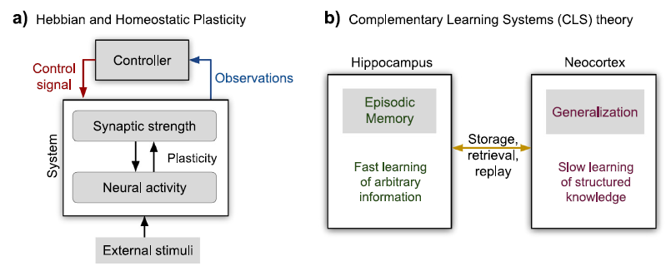

2.4. Learning without forgetting

Taken together, the biological aspects of lifelong learning summarized in this section provide insights into how artificial models and agents could prevent catastrophic forgetting and model graceful forgetting.

3. Lifelong learning and catastrophic forgetting in neural networks

3.1. Lifelong machine learning

3.2. Regularization approaches

Regularization approaches alleviate catastrophic forgetting by imposing constraints on the update of the neural weights.

Li and Hoiem (2016) proposed the learning without forgetting (LwF) approach composed of convolutional neural networks (CNN) in which the network with predictions of the previously learned tasks is enforced to be similar to the network with the current task by using knowledge distillation.

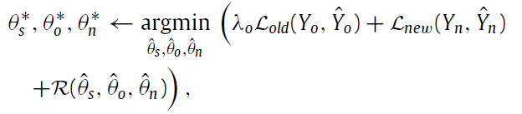

Kirkpatrick et al. (2017) proposed the elastic weight consolidation (EWC) model in supervised and reinforcement learning scenarios. The approach consists of a quadratic penalty on the difference between the parameters for the old and the new tasks that slows down the learning for task-relevant weights coding for previously learned knowledge.



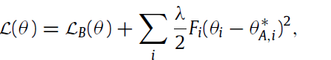

Zenke, Poole et al. (2017) proposed to alleviate catastrophic forgetting by allowing individual synapses to estimate their importance for solving a learned task.

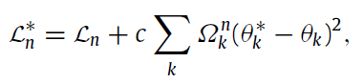

Maltoni and Lomonaco (2018) proposed the AR1 model for single-incremental-task scenarios which combines architectural and regularization strategies.

Ensemble methods have been proposed to alleviate catastrophic forgetting by training multiple classifiers and combine them to generate a prediction.

In summary, regularization approaches provide a way to alleviate catastrophic forgetting under certain conditions.

3.3. Dynamic architectures

Given N existing tasks, when a new task is TN+1 is given, a new neural network is created and the lateral connections with the existing tasks are learned.

3.4. Complementary learning systems and memory replay

Dual-memory learning systems have taken inspiration, to different extents, from the CLS theory to address catastrophic forgetting. An early computational example of this concept was proposed

by Hinton and Plaut (1987) in which each synaptic connection has two weights: a plastic weight with slow change rate which stores long-term knowledge and a fast-changing weight for temporary knowledge.

3.5. Benchmarks and evaluation metrics

Lopez-Paz and Ranzato (2017) defined training and evaluation protocols to assess the quality of continual learning models in terms of their accuracy as well as their ability to transfer knowledge between tasks. The transfer of knowledge can be forwards or backwards. The former refers to the influence that learning a task TA has on the performance of a future task TB, whereas the latter refers to the influence of a current task TB on a previous task TA. The transfer is positive when learning about TA improves the performance of another task TB (forwards or backwards) and negative otherwise.

Such guidelines comprise the use of three benchmark experiments: (i) data permutation, (ii) incremental class learning, and (iii) multimodal learning. The data permutation experiment consists in training a model with a dataset along with a permuted version of the same dataset, which tests the model’s ability to incrementally learn new information with similar feature representations. It is then expected that the model prevents catastrophic forgetting with the original data during the subsequent learning of randomly permuted data samples. In the incremental class learning experiment, the model performance reflects its ability to retain previously learned information while incrementally learning one class at a time. Finally, in the multimodal learning experiment, the same model is sequentially trained with datasets of different modalities, which tests the model’s ability to incrementally learn new information with dramatically different feature representations

4. Developmental approaches and autonomous agents

4.1. Towards autonomous agents

4.2. Developmental and curriculum learning

4.3. Transfer learning

Transfer learning refers to applying previously acquired knowledge in one domain to solve a problem in a novel domain. Forward transfer refers to the influence that learning a task TA has on the

performance of a future task TB, whereas backward transfer refers to the influence of a current task TB on a previous task TA (Fig. 5b).

4.4. Curiosity and intrinsic motivation

4.5. Multisensory learning

From a computational perspective, modelling multisensory learning can be useful for a number of reasons. First, multisensory functions aim at yielding robust responses in the case of uncertain and ambiguous sensory input. Second, if trained with multisensory information, one modality can be reconstructed from available information in another modality. Finally, mechanisms of attention are essential in lifelong learning scenarios for processing relevant information in complex environments and efficiently triggering goal-directed behaviour from continuous streams of multisensory information.

5. Conclusion

Lifelong learning represents an utterly interesting but challenging component of artificial systems and autonomous agents operating on real-world data, which is typically non-stationary and temporally correlated.